Now we have all of the different types of macroscopic energy that we will talk about in this course: kinetic energy $K=\frac{1}{2}mv^{2}$, gravitational potential energy $U_{g}=mgy$, and the potential energy of a spring $U_{s}=\frac{1}{2}kx^{2}$. These different types of energy can be organized as in the chart in the **FIGURE**. Collectively these types of energy are called *mechanical energy.*

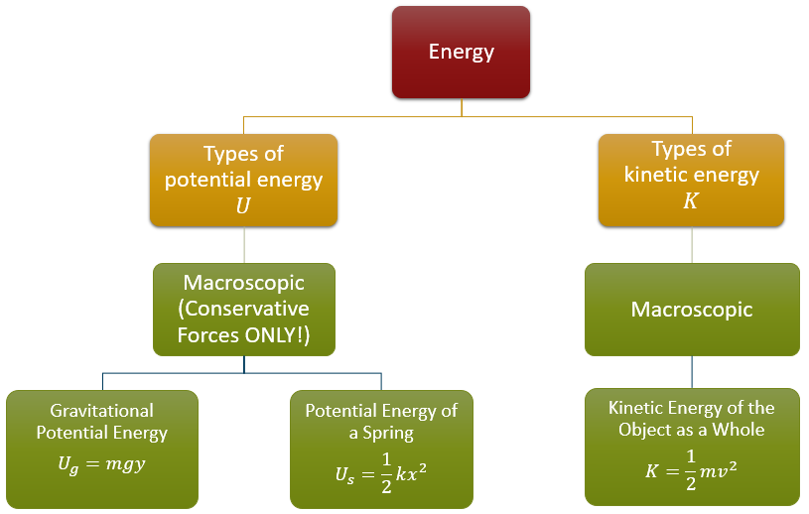

***FIGURE:*** *The different types of macroscopic (also called mechanical) energy*

Using these forms, and noting that heat is a microscopic process, we can write the law of conservation of energy as

$$ΔE=W$$

$$E_{f}-E_{i}=W$$

Where the work $W$ is the energy transferred into or out of the system by non-conservative forces. Knowing that the total energy is the sum of potential and kinetic energies, we can say that

$$(U_{f}+K_{f})-(U_{i}+K_{i})=W$$

which many people rearrange to look like

$$U_{i}+K_{i}+W=U_{f}+K_{f}$$

as this formulation separates the initial and final conditions. Finally, we could replace the potential energy $U$ with the types of potential energy are possible at the macroscopic scale: gravitational and springs. Such a replacement would leave us with

$$U_{g_{i}}+U_{s_{i}}+K_{i}+W=U_{g_{f}}+U_{s_{f}}+K_{f}$$

where $U_{g_{i}}$ is, for example, the initial gravitational potential energy.

This particular final form is very useful for analyzing situations in terms of energy. All we need to do to get started is:

* Identify what types of energy we have in a given situation
* Substitute the expressions for the gravitational potential energy $U_{g}=mgy$, spring potential energy $U_{s}=\frac{1}{2}kx^{2}$, and kinetic energy $K=\frac{1}{2}mv^{2}$
* Think about any energy entering or leaving the system as non-conservative work

The next section has some examples of this process for the special case where the energy entering or leaving the system as non-conservative work is zero; situations where the mechanical energy is conserved. These are the types of problems that we will expect you to be able to do on your homework and quiz. We will address the situation where energy is entering or leaving the system in class.